PHISHING WEBSITES DETECTOR
A report submitted to
Techno India University, West Bengal
for the partial fulfillment of Bachelor of Technology (B. Tech.) degree in
Computer Science & Engineering
with Artificial Intelligence (CSE_AI)
by :- PUSPENDU JANA
ID : 211003003102



DEPARTMENT OF COMPUTER SCIENCE & ENGINEERING TECHNO INDIA UNIVERSITY, WEST BENGAL,
SALT LAKE, KOLKATA – 700091, INDIA

May 2025
© 2025, Techno India University. All rights reserved.

CERTIFICATE

This is to certify that the Dissertation Report entitled, “PHISHING WEBSITES DETECTOR” submitted by “ PUSPENDU JANA ” to Techno India University, Kolkata, India, is a record of bonafide Project work carried out by them under my supervision and guidance and is worthy of consideration for the award of the degree of Bachelor of Technology (B.Tech) in Computer science & Engineering with Artificial Intelligence (CSE_AI) .

ACKNOWLEDGEMENT
I would first like to thank our thesis supervisor Prof. Lutfunnesa Khatun, Associate Professor, CSE_AI Dept, TIU. She helped us whenever we ran into a trouble spot or had a question about our research or writing.

I take this opportunity to express gratitude to all of the Department faculty members for their help and support.

I also thank our parents for the unceasing encouragement, support and attention and also sense of gratitude to one and all, who directly or indirectly, have bestowed their hand in this thesis.



Puspendu Jana

TABLE OF CONTENTS

ABSTRACT 6
LIST OF FIGURES 7
- INTRDUCTION 9
- OBJECTIVES 10
  - Primary Objectives 10
  - Secondary Objective 10
  - Long-Term-Goals 11
- PLANNING 12
  - Project Timeline 12
  - Milestones 13
  - Resources Allocation 13
  - Risk Management 14
- REQUIREMENT ANALYSIS 15
  - Functional Requirements 15
  - User Requirements 15
  - System Requirements 16
  - Non-Functional Requirements 17
- SYSTEM FLOW 19
  - USE-CASE DIAGRAM 19
  - ADMIN USE-CASE DIAGRAM 20
  - SEQUENCE DIAGRAM 21
- PROCESS DESIGN 24
  - Data Flow Diagram-Level 0 24
  - 1ST Level User side DFD 25
  - 1ST Level Admin Sdie DFD 26
- SYSTEM REQUREMENTS 27
  - Basic requirements 27
  - Using the code 27
  - Web Pages details 27
  - Project Detail 27
- LIST OF TABLES IN DATABASE 28
- ONLINE SHOPPING APPLICATION 30
  - HOME PAGE 30
  - REGISTER PAGE 31
  - LOGIN PAGE 31
  - CART PAGE (ORDERS) 32
  - PAYMENT PAGE (CHECKOUT) 33
  - CONTACT US PAGE 33
  - ABOUT PAGE 33
  - ADMIN LOGIN 34
  - ADMIN DASHBOARD PAGE 35
    - ADMIN REGISTERED USERS PAGE 35
    - ADMIN PRODUCT PAGE 35
    - ADMIN ORDERS PAGE 35
  - DATA DESCRIPTION 36

  - Data Objects
- ER DIAGRAM
- NON-FUNCTIONAL / OPERATIONAL REQUIREMENTS 21
  - SECURITY
  - EFFICIENCY AND MAINTAINABLITY
- CONCLUSION

- LINITATION OF E-COMMERCE PROJECT 40
- REFERENCE 41
- FUTURE SCOPE 42

List of Figures
HOME PAGE 30
REGISTER PAGE 31
LOGIN PAGE 31
CART PAGE 32
PAYMENT PAGE 32
ABOUT PAGE 33
CONTACT US PAGE 33
ADMIN LOGIN PAGE 34
ADMIN DASHBOARD PAGE 35
ADMIN REGISTERED USERS PAGE 35
ADMIN PRODUCTS PAGE 35

ABSTRACT
In today‟s fast-changing business environment, it‟s extremely important to be able to respond to client needs in the most effective and timely manner. If your customers wish to see your business online and have instant access to your products or services.
Online Shopping is a lifestyle e-commerce web application, which retails various fashion and lifestyle products (Currently Sterio Headphones). This project allows viewing various products available enables registered users to purchase desired products instantly using PayPal payment processor (Instant Pay) and also can place order by using Cash on Delivery (Pay Later) option. This project provides an easy access to Administrators and Managers to view orders placed using Pay Later and Instant Pay options.
In order to develop an e-commerce website, a number of Technologies must be studied and understood. These include multi-tiered architecture, server and client side scripting techniques, implementation technologies, programming language (such as Core PHP) and relational databases. This is a project with the objective to develop a basic website where a consumer is provided with a shopping cart application and also to know about the technologies used to develop such an application.
This document will discuss each of the underlying technologies to create and implement an e- commerce website.

List of Symbols, Abbreviations, and Nomenclature

Symbols:

Σ (Sigma):
  - Definition: Summation
  - Usage: Often used to denote the sum of a sequence of numbers or functions.
  - Example: Σ(i=1 to n) ai represents the sum of elements a1,a2,...,ana_1, a_2,
..., a_na1,a2,...,an.

λ (Lambda):
  - Definition: Wavelength or a parameter in certain functions.
  - Usage: Common in equations involving waves or in parameterized functions.
  - Example: λ = 500 nm denotes a wavelength of 500 nanometers.

μ (Mu):
  - Definition: Mean or average.
  - Usage: Often used to denote the mean of a set of values.
  - Example: μ = Σxi / N represents the average of the values x1,x2,...,xNx_1, x_2, ..., x_Nx1,x2,...,xN.

Ω (Omega):
  - Definition: Ohms (unit of electrical resistance) or a large set.
  - Usage: Used in electrical contexts or in set theory.
  - Example: R = 10 Ω denotes a resistance of 10 ohms.

π (Pi):
  - Definition: Mathematical constant (approximately 3.14159).
  - Usage: Used in formulas involving circles.
  - Example: C = 2πr represents the circumference of a circle.

Abbreviations:

API (Application Programming Interface):
  - Definition: A set of protocols and tools for building software and applications.
  - Usage: APIs enable different software components to communicate.
  - Example: RESTful API, SOAP API.

CSS (Cascading Style Sheets):
  - Definition: A style sheet language used for describing the presentation of a document written in HTML or XML.
  - Usage: Used to style web pages.
  - Example: CSS is used to change the font, color, and layout of a web page.

DB (Database):
  - Definition: An organized collection of data.
  - Usage: Used to store, retrieve, and manage data.
  - Example: MySQL, PostgreSQL.

HTML (HyperText Markup Language):
  - Definition: The standard language for creating web pages.

  - Usage: Used to structure content on the web.
  - Example: HTML tags like <div>, <h1>, <p> are used to organize content.

UAT (User Acceptance Testing):
  - Definition: A phase of software testing where the end users verify the system before it goes live.
  - Usage: Ensures that the software meets the business requirements.
  - Example: UAT is conducted before the final deployment.

Nomenclature:

Frontend:
  - Definition: The part of a website that users interact with directly.
  - Usage: Includes elements like HTML, CSS, and JavaScript.
  - Example: The homepage layout and design that users see and interact with.

Backend:
  - Definition: The server-side part of a website that handles business logic, database interactions, and server configurations.
  - Usage: Involves languages and frameworks like Node.js, Django, Ruby on Rails.
  - Example: The backend processes user login requests and retrieves user data from the database.

E-commerce:
  - Definition: Commercial transactions conducted electronically on the internet.
  - Usage: Refers to buying and selling goods and services online.
  - Example: Online stores like Amazon and eBay are e-commerce platforms.

UI (User Interface):
  - Definition: The space where interactions between humans and machines occur.
  - Usage: Involves design elements that users interact with.
  - Example: Buttons, forms, and menus on a website.

UX (User Experience):
  - Definition: A person's emotions and attitudes about using a particular product, system, or service.
  - Usage: Focuses on enhancing user satisfaction and accessibility.
  - Example: Ensuring that a website is easy to navigate and user- friendly contributes to a positive UX.

INTRODUCTION:
E-commerce is fast gaining ground as an accepted and used business paradigm. More and more business houses are implementing web sites providing functionality for performing commercial transactions over the web. It is reasonable to say that the process of shopping on the web is becoming commonplace.

The objective of this project is to develop a general purpose e-commerce store where product like headphones can be bought from the comfort of home through the Internet. However, for implementation purposes, this paper will deal with an online shopping for headphones.

An online store is a virtual store on the Internet where customers can browse the catalog and select products of interest. The selected items may be collected in a shopping cart. At checkout time, the items in the shopping cart will be presented as an order. At that time, more information will be needed to complete the transaction. Usually, the customer will be asked to fill or select a billing address, a shipping address, a shipping option, and payment information such as credit card number. An e-mail notification is sent to the customer as soon as the order is placed.

Objectives:

Primary Objectives:

User-Friendly Interface:
      - Goal: Design a website with an intuitive and easy-to-navigate interface.
      - Details: The website should have a clean layout, clear categories, and a search function that helps users find products quickly. Important features include user- friendly menus, filters, and sorting options to enhance the shopping experience.

Comprehensive Product Listings:
      - Goal: Provide detailed and comprehensive product listings for a wide range of musical instruments.
      - Details: Each product listing should include high-quality images, detailed descriptions, specifications, customer reviews, and pricing information. The goal is to ensure customers have all the information they need to make informed purchasing decisions.

Secure Payment Gateway:
      - Goal: Integrate a secure and reliable payment gateway to handle transactions.
      - Details: The payment system should support multiple payment methods (credit/debit cards, digital wallets, etc.) and ensure the security of user data through encryption and secure protocols.

Efficient Order Management System:
      - Goal: Implement an efficient system for managing orders, including processing, tracking, and delivery.
      - Details: The system should automate order processing, provide real- time updates on order status, and facilitate seamless communication between customers and the support team.

Secondary Objectives:

Customer Support:
      - Goal: Offer robust customer support to handle inquiries and resolve issues promptly.
      - Details: Provide multiple channels for customer support, such as live chat, email, and phone support. Implement a ticketing system to track and manage customer issues efficiently.

Marketing and Promotions:
      - Goal: Develop and implement effective marketing strategies to attract and retain customers.
      - Details: Use various marketing channels like social media, email newsletters, and SEO to promote the website. Offer promotions, discounts, and loyalty programs to encourage repeat purchases.

User Account Management:
      - Goal: Enable users to create and manage their accounts on the website.

      - Details: Allow users to create profiles, save their preferences, view order history, and manage their personal information. Implement features like wishlists and product recommendations to enhance user engagement.

Analytics and Reporting:
      - Goal: Implement tools for tracking and analyzing website performance and user behavior.
      - Details: Use analytics tools to monitor traffic, sales, and customer interactions. Generate reports to identify trends, measure the effectiveness of marketing campaigns, and make data-driven decisions.

Long-Term Goals:

Expansion of Product Range:
      - Goal: Continuously expand the range of musical instruments and accessories available on the website.
      - Details: Partner with more suppliers and brands to offer a wider selection of products. Keep up with market trends to introduce new and popular items regularly.

International Market Reach:
      - Goal: Extend the website‟s reach to international markets.
      - Details: Adapt the website for different languages and currencies. Implement international shipping options and address cross-border regulations to facilitate global sales.

Mobile App Development:
      - Goal: Develop a mobile app to complement the website and provide a seamless shopping experience on mobile devices.
      - Details: Create a mobile app with all the functionalities of the website, optimized for smartphones and tablets. Ensure the app offers a smooth and fast user experience.

Community Building:
      - Goal: Foster a community of musicians and music enthusiasts around the website.
      - Details: Implement features like forums, blogs, and user-generated content to engage users. Organize online events, contests, and workshops to build a loyal and active community.

Sustainability and Ethical Practices:
      - Goal: Promote sustainability and ethical practices in the supply chain and business operations.
      - Details: Partner with suppliers who follow ethical production practices. Implement eco-friendly packaging and reduce the carbon footprint of logistics and operations.

Chapter 3: Planning

Project Timeline
The project timeline outlines the key phases of development and their respective durations. The timeline is divided into six main phases, each with specific tasks and deliverables.

Phase 1: Research and Requirement Gathering (Month 1)
      - Market Research
      - Competitor Analysis
      - Stakeholder Meetings
      - Requirement Documentation

Phase 2: Design and Prototyping (Month 2-3)
      - Website Architecture Design
      - UI/UX Design
      - Prototype Development
      - User Feedback Collection and Iteration

Phase 3: Development (Month 4-6)
      - Frontend Development
      - Backend Development
      - Database Integration
      - API Development

Phase 4: Testing (Month 7)
      - Unit Testing
      - Integration Testing
      - User Acceptance Testing (UAT)
      - Bug Fixing and Refinement

Phase 5: Deployment (Month 8)
      - Server Setup
      - Domain and Hosting Configuration
      - Website Deployment
      - Initial Performance Monitoring

Phase 6: Post-Launch (Month 9 onwards)
      - Ongoing Maintenance
      - Feature Enhancements
      - Marketing and User Acquisition
      - Customer Support Setup

Milestones
Milestones are significant points or events in the project that mark the completion of major deliverables. The key milestones for the project are:

Milestone 1: Completion of Requirement Documentation (End of Month 1)

      - All requirements are documented and approved by stakeholders.

Milestone 2: Approval of Design and Prototype (End of Month 3)
      - UI/UX designs and prototypes are finalized and approved after user feedback.

Milestone 3: Completion of Core Development (End of Month 6)
      - The primary features and functionalities of the website are developed and integrated.

Milestone 4: Successful Testing and Bug Fixing
(End of Month 7)
      - All identified bugs are fixed, and the website passes UAT.

Milestone 5: Website Deployment (End of Month 8)
      - The website is live and accessible to users.

Milestone 6: Post-Launch Review (End of Month 9)
      - Initial performance and user feedback are reviewed, and necessary adjustments are made.

Resource Allocation
Resource allocation involves assigning available resources in an efficient manner to meet the project's goals. The key resources for this project include personnel, software, hardware, and budget.

Personnel:
      - Project Manager: Oversees the project, manages timelines, and coordinates team efforts.
      - Business Analyst: Gathers requirements, conducts market research, and liaises with stakeholders.
      - UI/UX Designer: Designs the website's user interface and user experience.
      - Frontend Developers: Implement the website's frontend using HTML, CSS, JavaScript, etc.
      - Backend Developers: Develop the server-side logic and database integration.
      - QA Testers: Conduct various tests to ensure the website functions correctly.
      - Marketing Team: Develops and executes marketing strategies post-launch.
      - Customer Support Team: Provides assistance to users post-launch.

Software:
      - Design Tools (e.g., Adobe XD, Figma)
      - Development Tools (e.g., VS Code, Git)
      - Testing Tools (e.g., Selenium, JUnit)
      - Project Management Tools (e.g., Jira, Trello)
      - Analytics Tools (e.g., Google Analytics)

Hardware:
      - Development Servers
      - Testing Environment
      - Production Servers

Budget:
      - Personnel Salaries

      - Software Licenses
      - Hosting and Domain Fees
      - Marketing and Advertising Costs
      - Miscellaneous Expenses

Risk Management
Risk management involves identifying potential risks, assessing their impact, and developing strategies to mitigate them. The key risks for this project include:

Technical Risks:
      - Risk: Integration issues with third-party APIs.
        - Mitigation: Conduct thorough testing and have backup APIs in place.

Project Management Risks:
      - Risk: Delays in project timeline due to unforeseen challenges.
        - Mitigation: Implement buffer times in the schedule and have contingency plans.

Security Risks:
      - Risk: Data breaches or cyber-attacks.
        - Mitigation: Use strong encryption, secure coding practices, and regular security audits.

Market Risks:
      - Risk: Lower-than-expected user adoption.
        - Mitigation: Conduct pre-launch marketing campaigns and user engagement activities.

Operational Risks:
      - Risk: Downtime during deployment.
        - Mitigation: Plan for off-peak deployment and have a rollback plan ready.

Financial Risks:
      - Risk: Budget overruns.
        - Mitigation: Regular budget reviews and cost control measures.

By carefully planning the project timeline, setting clear milestones, efficiently allocating resources, and proactively managing risks, the project can be guided to successful completion.

Chapter 4: Requirement Analysis

Functional Requirements
Functional requirements define the specific behaviors or functions of the system. These are divided into user requirements and system requirements.

User Requirements

User Registration and Login:
  - Users should be able to create an account using their email address or social media accounts.
  - Users should be able to log in using their credentials.
  - Password recovery options should be available.

User Profile Management:
  - Users should be able to update their personal information (name, address, contact details).
  - Users should be able to view their order history and track current orders.

Product Browsing and Searching:
  - Users should be able to browse musical instruments by category (e.g., string instruments, wind instruments, percussion).
  - Users should be able to search for specific products using keywords.
  - Filters should be available to narrow down search results by price, brand, type, etc.

Product Details:
  - Each product should have a detailed page with high-quality images, descriptions, specifications, pricing, and customer reviews.

Shopping Cart:
  - Users should be able to add products to a shopping cart.
  - Users should be able to view, update, or remove items from the cart.

Checkout and Payment:
  - Users should be able to proceed to checkout, enter shipping details, and select payment methods.
  - The system should support multiple payment options (credit/debit cards, PayPal, etc.).
  - Users should receive order confirmation and payment receipts.

Order Management:
  - Users should be able to view order status and track shipping.
  - Users should be notified of order updates via email/SMS.

Customer Support:
  - Users should have access to a help center with FAQs.
  - Users should be able to contact customer support via chat, email, or phone.

System Requirements

Admin Dashboard:
  - Admins should be able to manage product listings (add, update, delete).
  - Admins should be able to view and manage user accounts.
  - Admins should be able to view and manage orders, including processing and shipping.
  - Admins should be able to generate sales and performance reports.

Inventory Management:
  - The system should track product inventory levels.
  - Admins should receive notifications when stock levels are low.

Content Management:
  - Admins should be able to manage website content, including homepage banners, blogs, and promotional materials.

Analytics and Reporting:
  - The system should provide detailed analytics on website traffic, user behavior, sales, and marketing campaign effectiveness.

Security Management:
  - The system should include features for role-based access control, ensuring only authorized users can perform certain actions.
  - Regular security audits and monitoring should be in place.

Non-Functional Requirements
Non-functional requirements define the quality attributes of the system, such as performance, security, and usability.

Performance

Speed and Responsiveness:
        - The website should load within 3 seconds on a standard broadband connection.
        - Transactions and page navigations should be processed with minimal delay.

Scalability:
        - The system should be able to handle increasing numbers of users and transactions without performance degradation.
        - The infrastructure should support horizontal scaling to accommodate traffic spikes.

Availability:
        - The system should have an uptime of at least 99.9%, ensuring high availability for users.

Security

Data Protection:
        - All sensitive user data should be encrypted, both at rest and in transit.
        - The system should comply with data protection regulations such as GDPR and CCPA.

Authentication and Authorization:
        - Implement multi-factor authentication (MFA) for user and admin logins.
        - Role-based access control should ensure users have appropriate permissions.

Vulnerability Management:
        - Regular security audits and vulnerability assessments should be conducted.
        - Implement intrusion detection and prevention systems (IDPS) to monitor and mitigate threats.

Usability

User Experience:
        - The website should have an intuitive and user-friendly design, ensuring ease of navigation.
        - Provide a consistent user experience across different devices (responsive design).

Accessibility:
        - Ensure the website is accessible to users with disabilities by following Web Content Accessibility Guidelines (WCAG).
        - Include features like text-to-speech, keyboard navigation, and alternative text for images.

Support and Documentation:
        - Provide comprehensive user guides and FAQs to assist users in navigating the website.
        - Implement a feedback system to gather user input for continuous improvement.

Chapter 5: System Flow
  - Use Case Diagrams

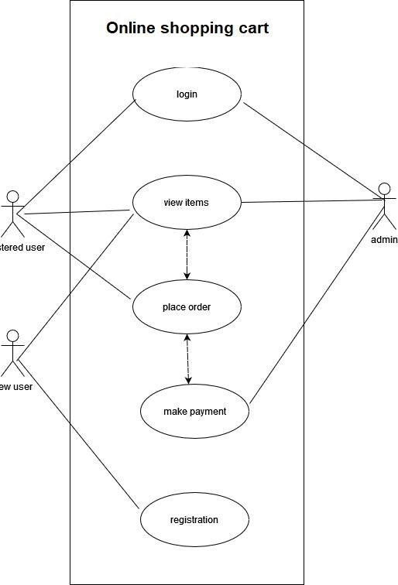

  - Admin Use Case Diagrams



Manage
Products
Manage
Users
Manage
Orders
View
Reports
Admin
Update
Website

  - Sequence Diagrams
Sequence diagrams illustrate the sequence of messages exchanged between objects to perform specific functions. They show how processes operate with one another and in what order.


User Registration Sequence Diagram
Register(Input)
Verify Input ()

Verification Result
Valid Input
Add new user
Redirect to Main Page
Invalid Input
Display Error
z
Database
Registration Page
User
Main Page

Similarly, we can produce each diagram using following points.

Product Purchase Sequence Diagram
      - User adds product to cart.
      - System updates cart.
      - User proceeds to checkout.
      - System displays checkout form.
      - User submits payment details.
      - System processes payment.
      - System confirms order and updates inventory.
      - System sends order confirmation to User.

Admin Managing Products Sequence Diagram
      - Admin logs into the system.
      - System displays admin dashboard.
      - Admin selects manage products option.
      - System displays product management interface.
      - Admin adds/updates/deletes product details.
      - System updates product database.

Activity Diagrams
Activity diagrams illustrate the flow of activities and decisions in a process. They are useful for modeling the control flow from one activity to another.

User Registration Activity Diagram

Start
      - Display registration form
      - User enters details
- [Decision: Valid Details?]
  - Yes: Create account
  - No: Display error message
      - Send confirmation email
      - End

Product Purchase Activity Diagram

Start
      - User adds product to cart
      - User proceeds to checkout
      - Display checkout form
      - User enters payment and shipping details
- [Decision: Valid Details?]
  - Yes: Process payment
  - No: Display error message
      - Confirm order
      - Update inventory
      - Send confirmation email
      - End

Order Management Activity Diagram

Start
      - User logs in
      - User views order history
      - User selects order to track
      - Display order status
- [Decision: Order Delivered?]
  - Yes: End
  - No: Continue tracking
      - End

Chapter 6: Proposed Design

DATA FLOW DIAGRAM-LEVEL 0:
The context level data flow diagram (dfd) is describe the whole system. The (o) level dfd describe the all user module who operate the system. Below data flow diagram of online shopping site shows the two user can operate the system Admin and Member user.

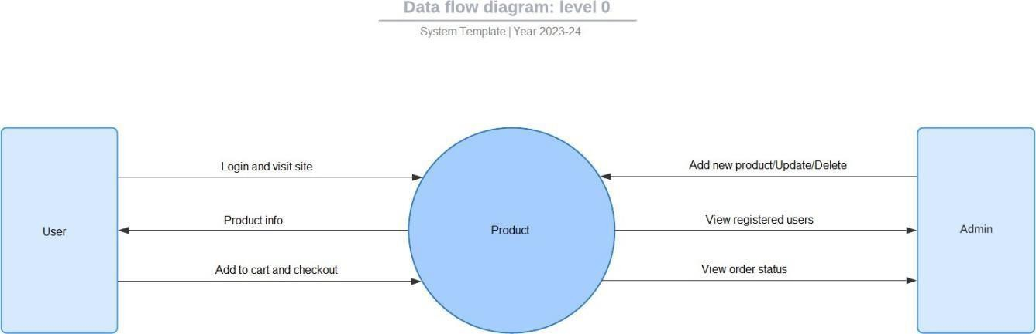

1ST LEVEL USER SIDE DFD
The user is all people who operate or visit our website. User is a customer of a website. User can first select product for buy, user must have to register in our system for purchase any item from our website. after register he can login to site and buy item by making online payment through any bank debit card or credit card, or pay on delivery.

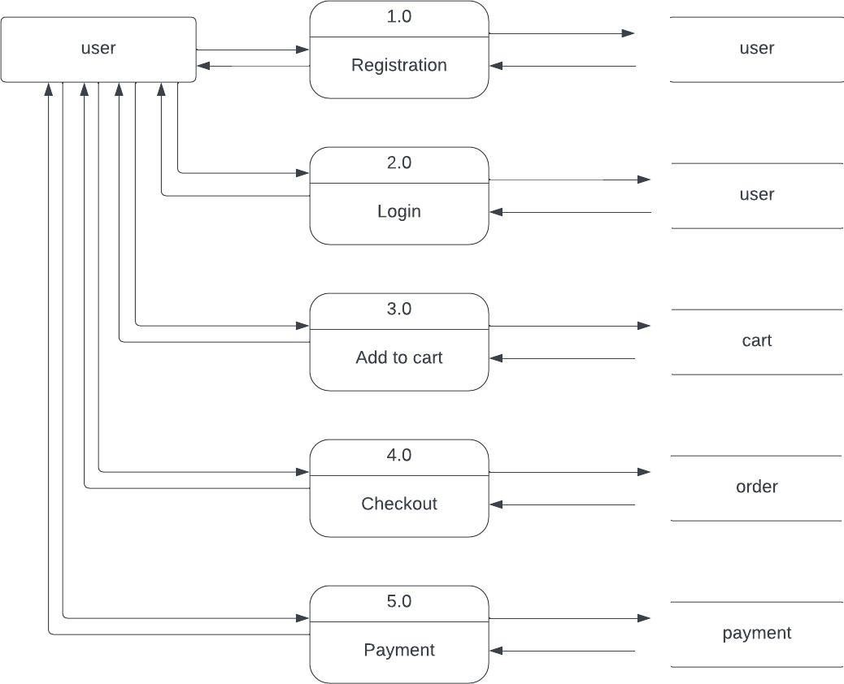

1ST LEVEL ADMIN SIDE DFD:
The Admin side DFD describe the functionality of Admin, Admin is a owner of the website. Admin can first add category of item and then add items by category wise. and admin can manage order and payment detail.

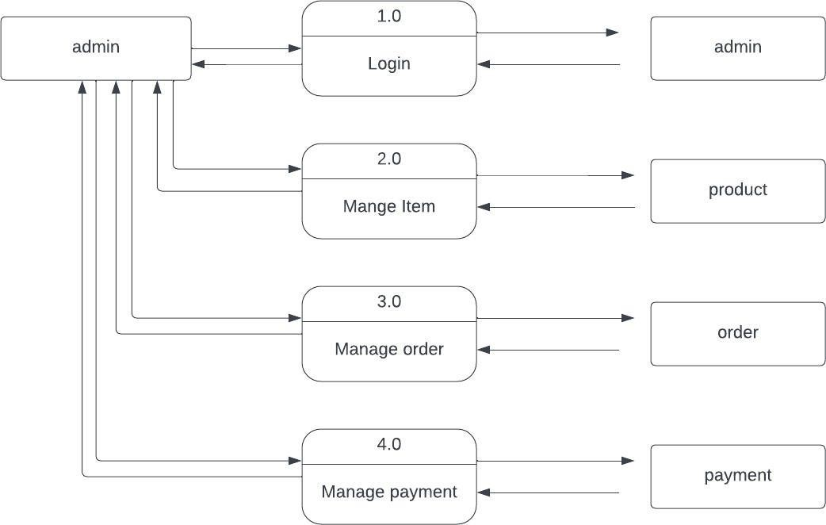

SYSTEM REQUREMENTS:

Basic requirement:
    - HTML
    - CSS
    - Bootstrap 5
    - JavaScript
    - jQuery
    - PHP
    - MySql
    - Font Awesome
    - Google font

Using the code:
- Attach the database in your "WAMPP SERVER".
- Run the application on VS Code as web site.
- Locate the database.

Web Pages details:







Home Page About Page Cart Page Contact Page Admin Page Login Page Register Page

Project Detail:
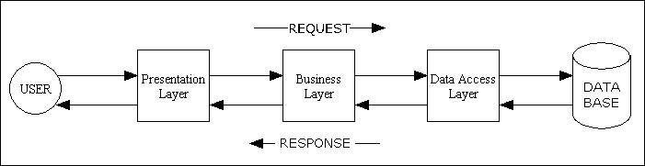

List of Tables In Database

TABLES
Table Name: users
Column Name | Type
u_id | int
fname | varchar
lname | varchar
emal | varchar
password | varchar
Table Name: product
Column Name | Type
p_id | int
p_name | varchar
image | varchar
description | varchar
price | int
pcode | varchar
Table Name: cart
Column Name: | Type
p_id | int
p_name | varchar
price | int
image | varchar
qty | int
total_price | decimal
pcode | varchar
user_id | int

Table Name: order
Column Name: order_id | Type | int
user_id |  | int
fullname |  | varchar
phone |  | varchar
email |  | varchar
pincode |  | varchar
address |  | varchar
total_price |  | decimal
oder_date |  | timestamp

Table Name: admin

Column Name: Type
id int
username varchar
password varchar

ONLINE SHOPPING APPLICATION:

Anyone can view Online Shopping portal and available products, but every user must login by his/her Username and password in order to purchase or order products. Unregistered members can register by navigating to registration page. Only Admin will have access to modify roles, by default developer can only be an „Admin‟. Once user register site, his default role will be „User‟.

  - HOMEPAGE: The Home Screen will consist of screen were one can browse through the products which we have on our website.

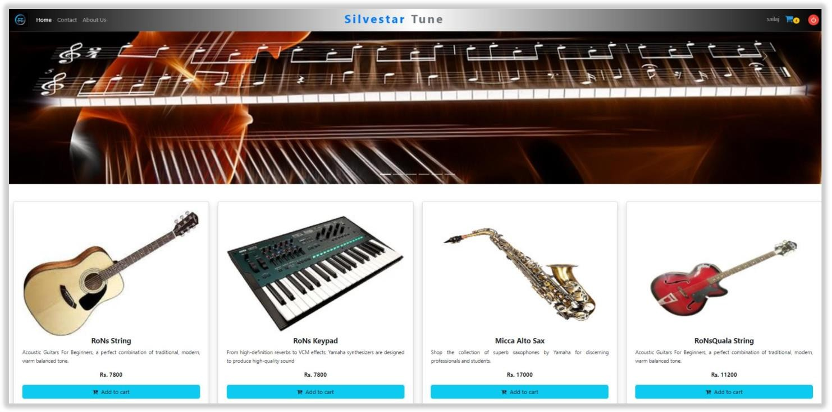

  - REGISTER PAGE: New user can register here.
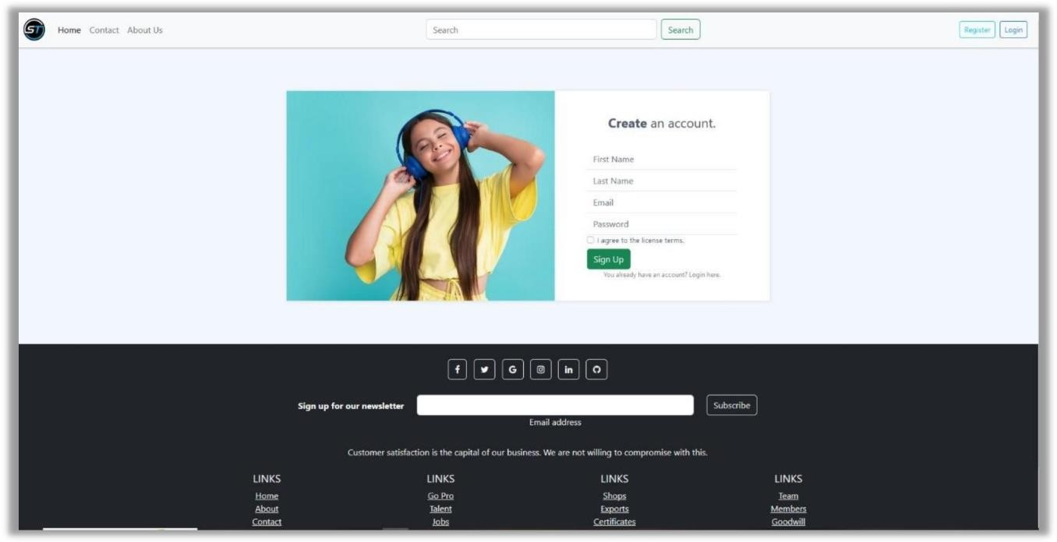

  - LOGIN PAGE: Registered user can login from here.
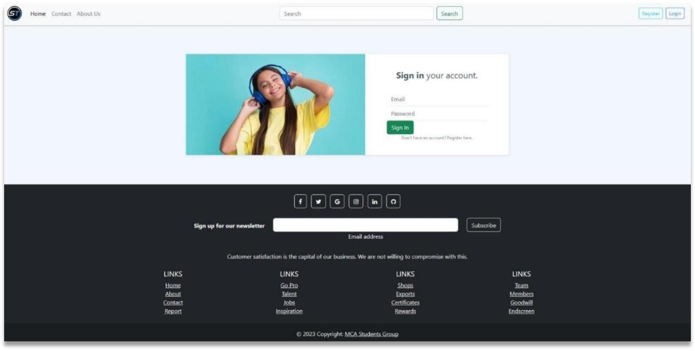

  - CART PAGE (After adding to cart): This page consists of product order by customer and calculate grand total. Customer can clear cart anytime or checkout for proceed to buy.
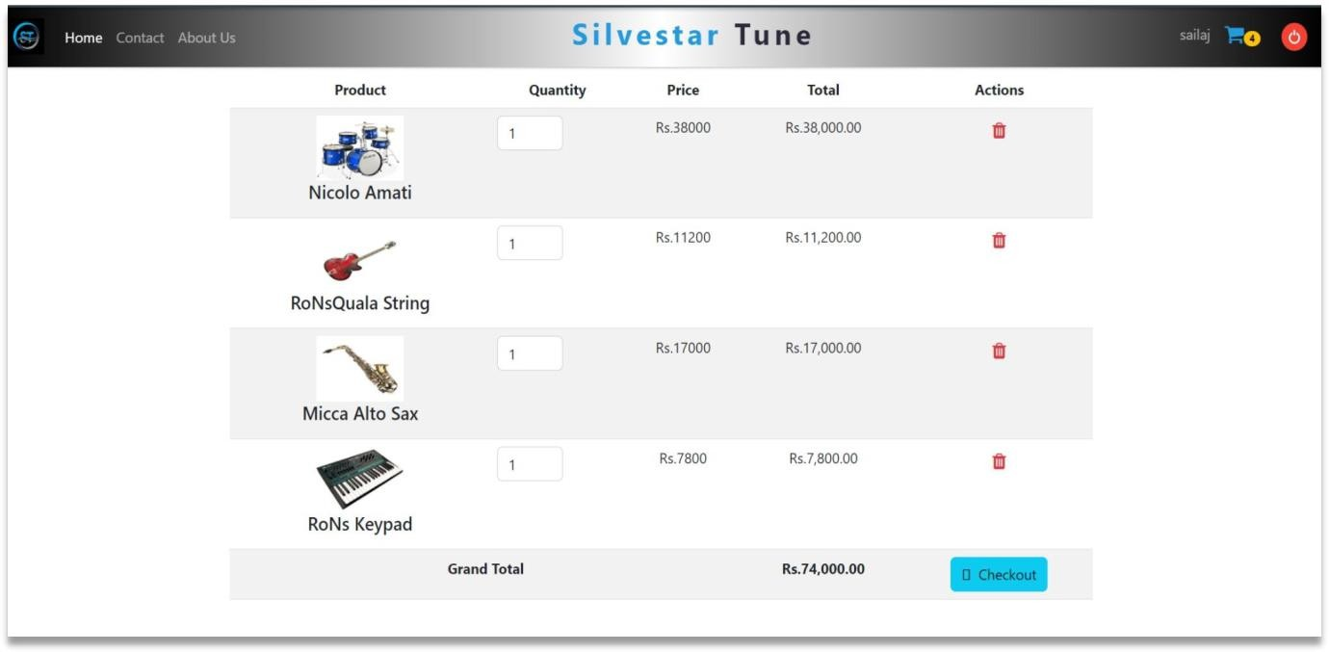

  - PAYMENT PAGE: This is the final page through which, customer can pay for their orders.
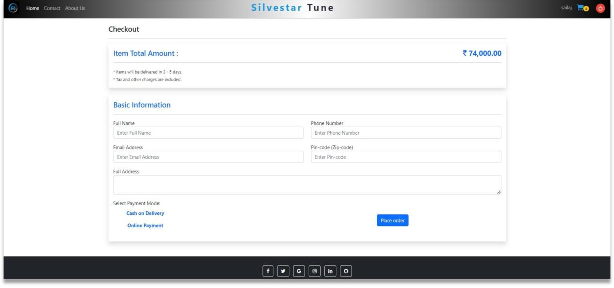

  - ABOUT PAGE: Simple about page using bootstrap 5 express the gyst of the company and their products. Through this page a company highlights their goodwill, brand and logo.

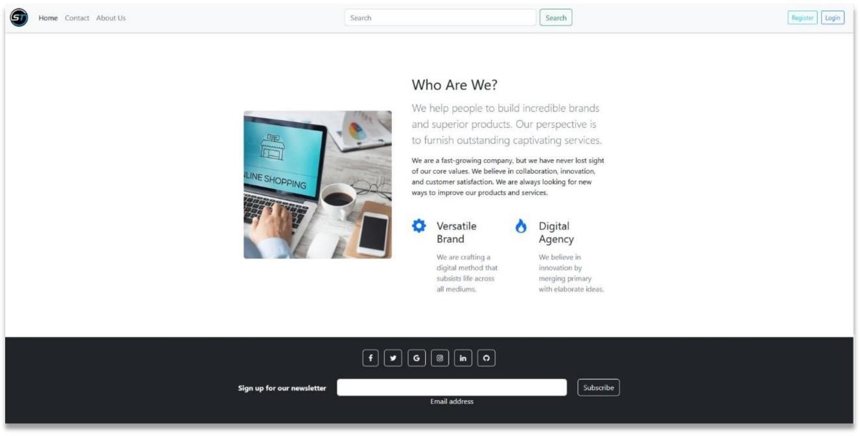

  - CONTSCT US PAGE: Any visitor with or without login, can contact to the company for any query with this page. This page can help them to get proper information of product and price.
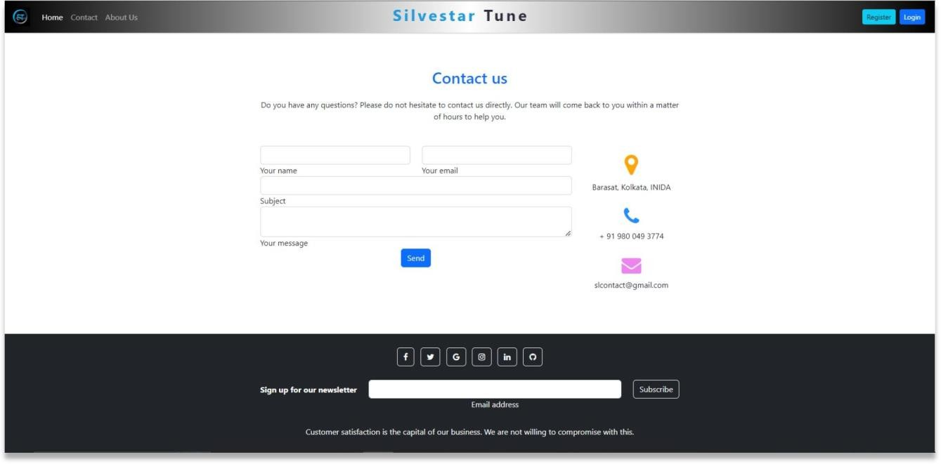

  - ADMIN LOGIN PAGE: Only difference you see in this page is Role: Admin. User and Admin role will be checked once the page was login and Session [“role”] will be either Admin or User. If credentials belong to Admin then role will be Admin and if credentials belong to User then role will be User.
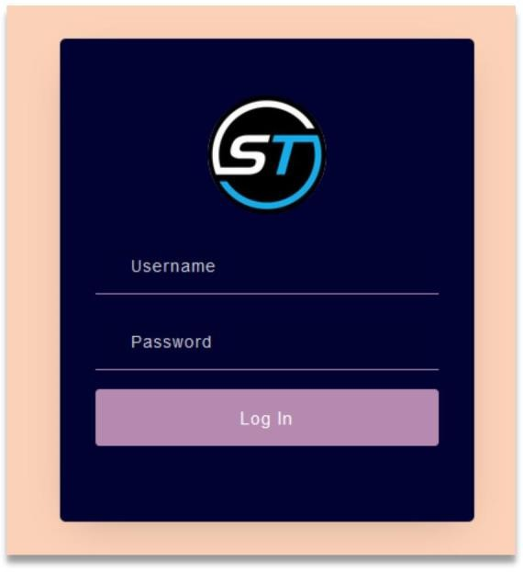

  - ADMIN DASHBOARD PAGE: This page shows three categories, such as list of registered users and their credentials, all products along with images and other details and list of orders by customers. No redadymade framework is used here. The entire Admin panel is created with core PHP.

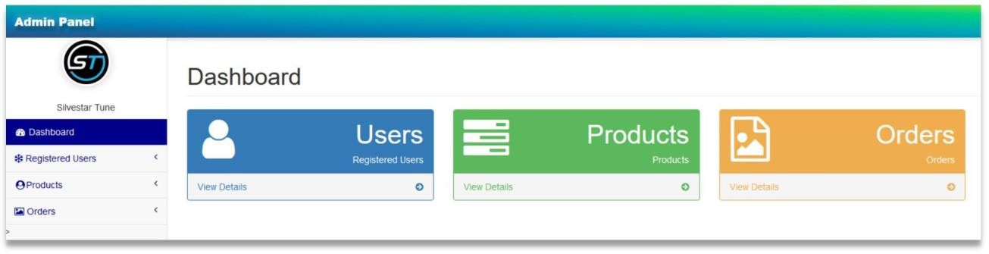

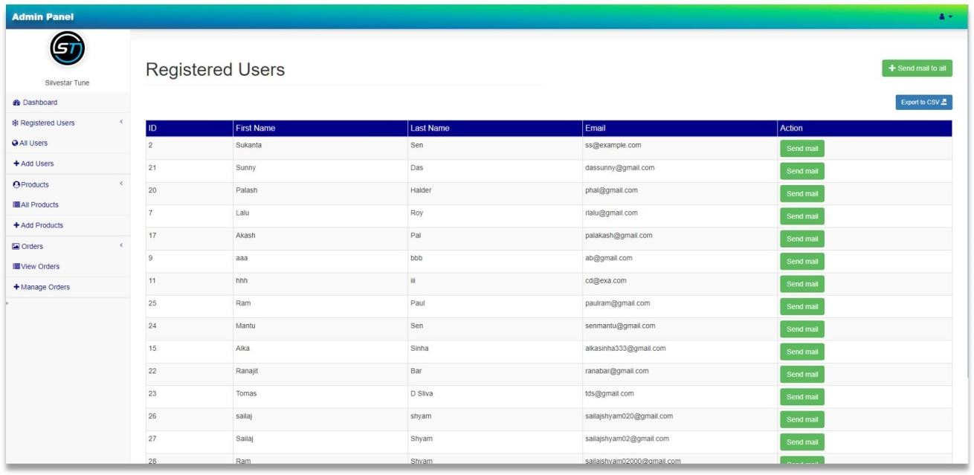
ADMIN REGISTERED USERS PAGE: Through this page, an Admin can view the list of registered users and their credentials. Admin can add or remove users form here. Also he or she can send mail to either individual user or all users.

ADMIN PRODUCTS PAGE: This page shows all the products that have already been displaying in the home page. Admin can add new product, remove existing product and edit product image, price, or description, discount etc.
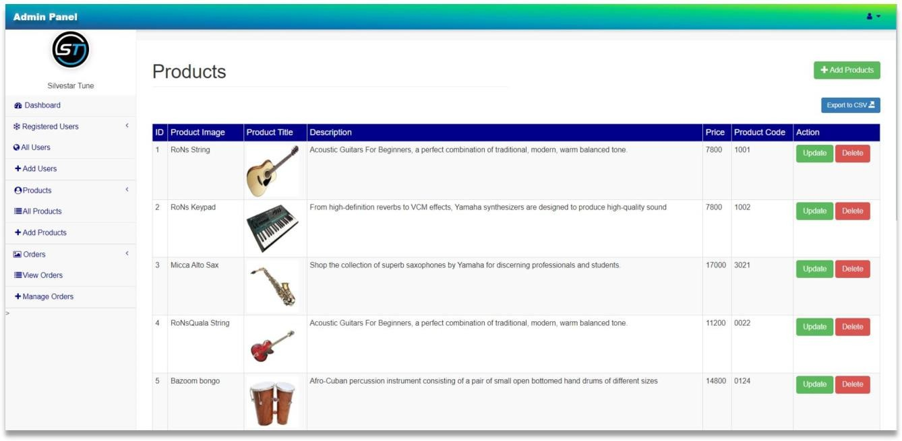

Data Description
This database consists of
Users: User and Admin information is added to database with Unique ID based on their roles.
Cart: Complete products information is stored in this table.
Orders: Customer ordered products, status and delivery information is stored in this table.

Data Objects
User: u_id, fname, lname, email, password
Products: p_id, p_name, Image, Description, price, pcodeOrders: id, total_price, u_id, p_id

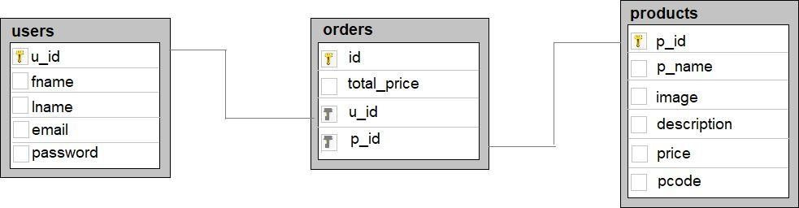

E-R Diagram:

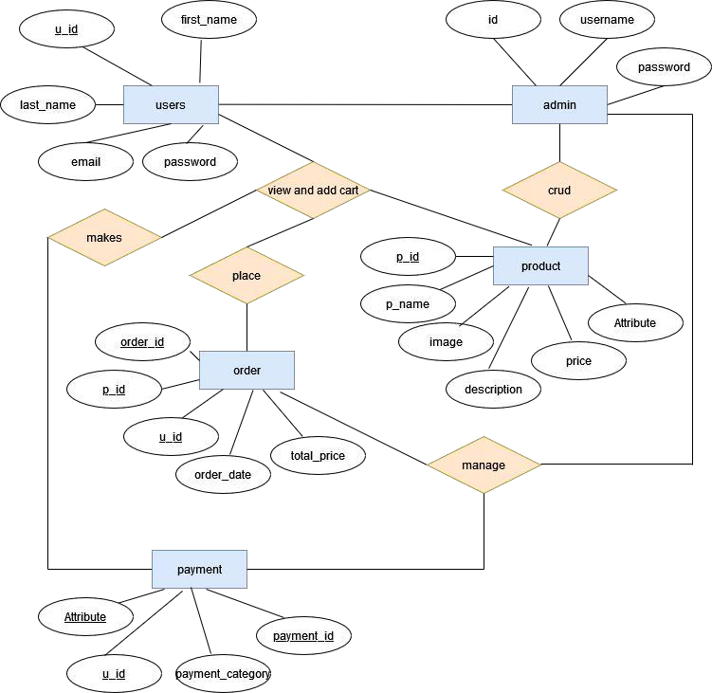

- Non-Functional / Operational Requirements


Security
Pages of the website must be access in the way they were intended to be accessed.
Included files shall not be accessed outside of their parent file.

Administrator can only perform administrative task on pages they are privileged to access. Customers will not be allowed to access the administrator pages.


Efficiency and Maintainability
Page loads should be returned and formatted in a timely fashion depending on the request being made.

Administrators will have the ability to edit the aspects of the order forms, product descriptions, prices and website directly.

Chapter 13: Conclusion

Summary of Work Done
This project aimed to develop an e-commerce website for musical instruments, providing a comprehensive platform for users to purchase a variety of musical instruments and accessories online. The development process involved several key phases:

    - Requirement Analysis: Gathering and documenting the functional and non- functional requirements, including user and system requirements.
    - Design and Prototyping: Creating the website architecture, user interface (UI), and user experience (UX) designs, and developing prototypes for user feedback.
    - Development: Implementing the front-end and back-end of the website, integrating databases, and ensuring seamless functionality.
    - Testing: Conducting unit, integration, and user acceptance testing to identify and fix bugs, ensuring a robust and reliable system.
    - Deployment: Configuring the server, deploying the website, and performing initial performance monitoring.
    - Post-Launch Activities: Providing ongoing maintenance, feature enhancements, marketing efforts, and customer support.

Achievements
Several notable achievements were accomplished during the project:

- User-Friendly Interface: Developed an intuitive and visually appealing interface that enhances the user experience.
- Comprehensive Product Listings: Successfully implemented detailed product pages with high-quality images, descriptions, specifications, and customer reviews.
- Secure Payment Gateway: Integrated a secure and reliable payment gateway supporting multiple payment methods, ensuring safe transactions.
- Efficient Order Management: Implemented a system that handles order processing, tracking, and notifications, streamlining the order management process.
- Robust Admin Dashboard: Created an admin dashboard for efficient product, user, and order management, along with detailed analytics and reporting tools.
- Customer Support System: Established a help center and multiple support channels to assist users with their queries and issues.

Challenges Faced
Several challenges were encountered and addressed during the project:

- Requirement Changes: Adapting to evolving requirements and feedback from stakeholders and users required flexibility and frequent updates to the project plan.

- Technical Integration: Integrating various third-party APIs for payment processing, shipping, and analytics posed technical challenges that were overcome through thorough testing and troubleshooting.
- Performance Optimization: Ensuring the website's speed and responsiveness required optimization of code, efficient database queries, and scalable infrastructure.
- Security Concerns: Implementing robust security measures to protect user data and transactions involved regular security audits and updates to address potential vulnerabilities.
- User Engagement: Developing effective marketing strategies and engaging users in a competitive e-commerce market required continuous effort and innovation.

Final Thoughts
The development of the e-commerce musical instrument-based website has been a comprehensive and rewarding journey. The project successfully created a platform that meets the needs of both users and administrators, offering a seamless shopping experience for musical instruments and accessories. The achievements in user interface design, secure payment processing, and efficient order management have laid a strong foundation for future growth and enhancement.

Moving forward, continuous improvement and adaptation to market trends will be crucial. Future developments may include expanding the product range, enhancing mobile usability, and exploring new marketing strategies to reach a broader audience. By maintaining a focus on user satisfaction and technological advancements, the website can continue to thrive and provide value to its users.

This project has not only provided valuable insights into e-commerce website development but also demonstrated the importance of meticulous planning, collaboration, and problem- solving in achieving project goals. The lessons learned and experiences gained will be instrumental in guiding future endeavors in the field of web development and e-commerce.

Chapter 14.0 Future Scope of the Project:
In a nutshell, it can be summarized that the future scope of the project circles around maintaining information regarding:
- We can add more products in future.
- We can have categorized products so that user can easily find them.
- We can give more advance software for Online Musical Instrument Ordering System including more facilities
- We will host the platform on online servers to make it accessible worldwide
- Integrate multiple load balancers to distribute the loads of the system
- Create the master and slave database structure to reduce the overload of the database queries
- Implement the backup mechanism for taking backup of codebase and database on regular basis on different servers.

The above mentioned points are the enhancements which can be done to increase the applicability and usage of this project. Here we can maintain the records of Food and Item Category. Also, as it can be seen that now-a-days the players are versatile, i.e. so there is a scope for introducing a method to maintain the Online E-commerce System. Enhancements can be done to maintain all the
Product, Item Category, Shopping Cart, Customer, Order.
We have left all the options open so that if there is any other future requirement in the system by the user for the enhancement of the system then it is possible to implement them. ln the last we would like to thanks all the persons involved in the development of the system directly or indirectly. We hope that the project will serve its purpose for which it is develop there by underlining success of process.

Chapter 15. Limitation of project on Online E- commerce System
Although We have put our best efforts to make the website flexible, easy to operate but limitations cannot be ruled out even by us. Though the software presents a broad range of options to its userssomeintricate options could not be covered into it; partly because of logistic and partly due to lackof sophistication. Paucity of time was also major constraint, thus it was not possible to make the software oolproof and dynamic. Lack of time also compelled us to ignore some part. Considerable efforts have made the software easy to operate even for the people not related to the field of computers but it is acknowledged that a layman may find it a bit problematic at the first instance. The user is provided help at each step for his convenience in working with the software.
List of limitations which is available in the Online E-commerce System:
- Excel export has not been developed for Selling Products, Item Category due to some criticality.
- The transactions are executed in off-line mode, hence on-line data for Shopping Cart, Customer capture and modification is not possible.
- Off-line reports of Products, Order, Shopping Cart cannot be generated due to batch mode execution.

16.0 REFERENCE:
- The Joy of PHP Programming: A Beginner‟s Guide – by Alan Forbes.
- Learning PHP, MySQL, JavaScript, and CSS: A Step-by-Step Guide to Creating Dynamic Websites – by Robin Nixon.
- https://www.w3schools.com/
- https://getbootstrap.com/docs/5.0/getting-started/introduction/
- https://youtu.be/RyZTcwCc-jQ?list=PL6u82dzQtlfsQoq15 a6oRLLwvkhGu43

17.0. FUTURE SCOPE:
Admin Panel Manage Orders: In this section we will upgrade the admin panel in such a way that the admin can easily know whether the order payment is by card or cash on delivery. That way admin can manage any order.

Admin Register Users Page: Later on admin register User Page, admin can mail any individual user or send greeting mail to all users.

Product categories: Subsequently, the product category is going to grow more. Along with headphones, there will be various electronics gadgets like mobile phones, mobile phone accessories, home theater systems etc. product category wise. The user can go to the category navbar and click for the category they want to see.

Footer section: All social media links provided in footer section will be active in coming days.

Contact Us Page: This page is currently inactive. In near future users will be able to upload their queries and complaints on this page.

Search Button: This button is currently inactive. In near future users will be able to search their required product according to category wise.

